#ALTER

ALTER TABLE *table_name*

ADD *column_name datatype*;

ALTER TABLE *table_name*

DROP COLUMN *column_name*;

My SQL / Oracle (prior version 10G):

ALTER TABLE *table_name*

MODIFY COLUMN *column_name datatype*;

Oracle 10G and later:

ALTER TABLE *table_name*

MODIFY *column_name datatype*;

CREATE TABLE employee (

emp_id INT ,

first_name VARCHAR(40),

super_id INT,

branch_id INT,

CONSTRAINT pk_employee PRIMARY KEY (emp_id),

CONSTRAINT fk_employee_employee FOREIGN KEY (super_id)

REFERENCES employee(emp_id) ON DELETE SET NULL

);

CREATE TABLE branch(

branch_id INT,

branch_name VARCHAR(40),

mgr_id INT,

mgr_start_date DATE,

CONSTRAINT pk_branch PRIMARY KEY (branch_id),

CONSTRAINT fk_branch_employee FOREIGN KEY (mgr_id)

REFERENCES employee(emp_id) ON DELETE SET NULL);

ALTER table employee

ADD CONSTRAINT fk_employee_branch FOREIGN KEY (branch_id)

REFERENCES branch(branch_id)

ON DELETE SET NULL ;

INSERT INTO Teacher (Tcode, TFName, TLName) VALUES ('T04', 'อภิศักดิ์' , 'พัฒนจักร');

INSERT INTO Borrow VALUES(1, '623021039-4' , 'B01', TO_DATE('24/2/2015','DD/MM/YYYY'), TO_DATE('25/2/2015','DD/MM/YYYY'));

CREATE VIEW LAB6_BookBorrow AS

SELECT BOOKID, BOOKNAME, COUNT(*) - 1 Amount

FROM(

SELECT BOOKID, BOOKNAME

FROM BOOK

UNION ALL

SELECT BORROW.BOOKID, BOOK.BOOKNAME

FROM BORROW

INNER JOIN BOOK on BOOK.BOOKID = BORROW.BOOKID

)

GROUP BY BOOKID, BOOKNAME

ORDER BY BOOKID;

select 'i like' || type_column || ' with' ect....

#Other important keywords

LEFT OUTER JOIN, MIN, MAX, AVG, SUM

WITH a AS

( SELECT name, birthdate, YEAR(birthdate) AS birthyear

FROM persons

WHERE birthdate >= '1950-01-01' AND birthdate < '1960-01-01'

)

, b AS

( SELECT birthyear, COUNT(*) AS cnt

FROM a

GROUP BY birthyear

)

SELECT a.name, a.birthdate, b.cnt AS number_of_births

FROM a JOIN b

ON a.birthyear = b.birthyear

WHERE MONTH(a.birthdate) = 7 ;

SELECT DISTINCT column1, column2, ...  
FROM table_name;

ELECT * FROM Customers

ORDER BY Country ASC, CustomerName DESC;

WHERE column_name IS NULL;

WHERE column_name IS NOT NULL;

UPDATE table_name  
SET column1 = value1, column2 = value2, ...  
WHERE condition;

DELETE FROM Customers

WHERE CustomerName='Alfreds Futterkiste';

SELECT column_name(s)  
FROM table_name  
WHERE ROWNUM <= number;

SELECT MIN(column_name) #MAX  
FROM table_name  
WHERE condition;

SELECT column1, column2, ...  
FROM table_name  
WHERE columnN LIKE pattern;

SELECT column_name(s)

FROM table_name

WHERE column_name IN (value1, value2, ...);

SELECT * FROM Customers  
WHERE Country IN (SELECT Country FROM Suppliers);

SELECT column_name(s)  
FROM table_name  
WHERE column_name BETWEEN value1 AND value2;

SELECT OrderID, Quantity,  
CASE  
    WHEN Quantity > 30 THEN 'The quantity is greater than 30'  
    WHEN Quantity = 30 THEN 'The quantity is 30'  
    ELSE 'The quantity is under 30'  
END AS QuantityText  
FROM OrderDetails;

SELECT Employees.LastName, COUNT(Orders.OrderID) AS NumberOfOrders  
FROM (Orders  
INNER JOIN Employees ON Orders.EmployeeID = Employees.EmployeeID)  
GROUP BY LastName  
HAVING COUNT(Orders.OrderID) > 10;

ALTER TABLE table_name  
ADD column_name datatype;

ALTER TABLE table_name  
DROP COLUMN column_name;

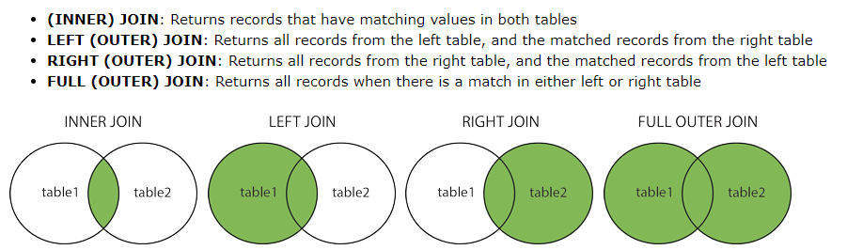

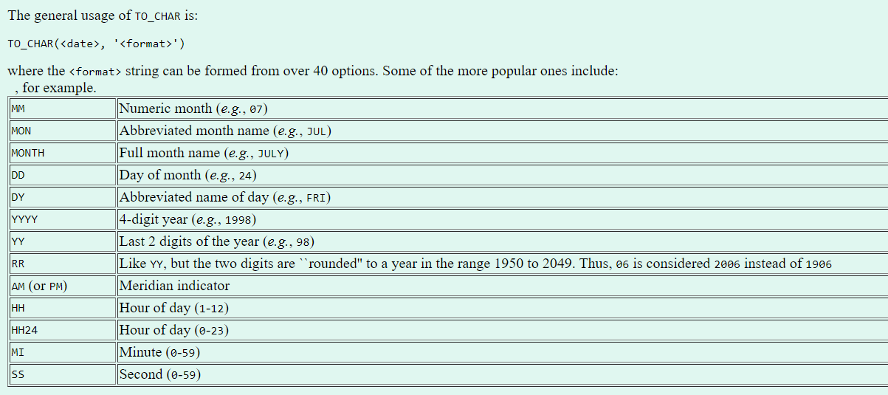

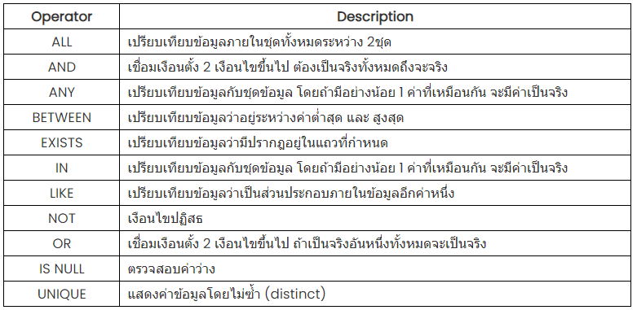

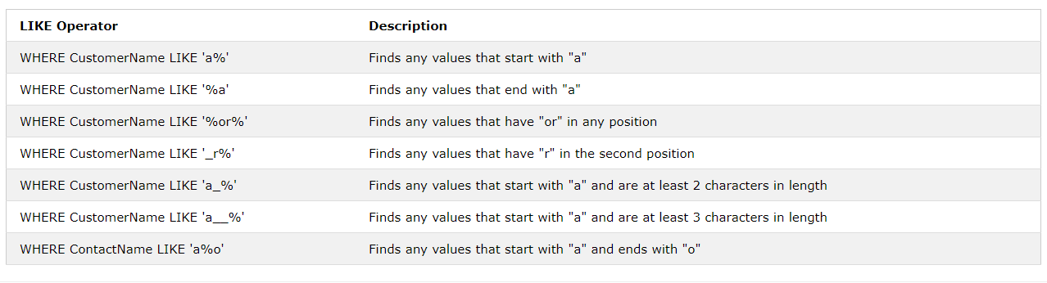

SELECT SupplierName

FROM Suppliers

WHERE EXISTS (SELECT ProductName FROM Products WHERE Products.SupplierID = Suppliers.supplierID AND Price < 20);

SELECT column_name(s)  
FROM table_name  
WHERE column_name operator ANY | ALL  
(SELECT column_name FROM table_name WHERE condition);

Note: The operator must be a standard comparison operator (=, <>, !=, >, >=, <, or <=).

CREATE USER ucs2

IDENTIFIED BY p123

DEFAULT TABLESPACE users

TEMPORARY TABLESPACE temp

QUOTA UNLIMITED ON users;

//ให สิทธิ์

GRANT resource, connect To ucs2;

GRANT <prib/rol> TO <myUser>